Sprint Challenge 2 – Adam Kovar
- The 360 Degree View
Creating a 360 degree view of a problem is essentially a holistic view of considering every aspect of the issue at hand. In class, we categorized aspects into four main buckets to simplify the analysis and allow the 360 degree view to become a sum of these four 90 degree segments: internal (issues that are within control of the source), external (issues outside the source’s control), temporal (historical impacts and time related issues), and composite (the issues that intertwine the aforementioned three segments).
When we look at predicting tournament play in March Madness, there are untenable amounts of research and hours poured into attempting to pinpoint the perfect combination of attributes in order to predict tournament success. The 360 degree view manifests in utilizing internal team metrics like traditional basketball statistics, external vantage points through team seeding, temporal effects like past tournament trends, and composite metrics like team’s NET ranking that combine their strength of schedule and statistical output throughout the regular as well as post season. The SEC survey that we reviewed in class can also be broken down with the same criteria: internal in this case represents stadium related operations, external represents elements of the gameday experience outside of the stadium, temporal being the frequency of attendance and timing of operations, while composite represents the blending of stadium operations (video boards, restrooms, music, etc.) and the gameday operations (parking and ticketing).
In addition to the two class examples, Karim Kassam gave a presentation at MIT SLOAN on the closing gap in analytics between the NFL and college football. The college football space, while extremely profitable for universities and one of the country’s most watched sports every week, has lagged behind its professional counterpart in terms of analytical advancement. The wide range of resources available to each college football program, though all mostly concentrated on staff salary and team expenses, puts a strain on the overall advancement of the analytics field across the sport. Additional internal issues such as limited in person evaluation of prospects and small scouting departments have restricted the ability of teams to build out complex analytics solutions to deal with the changing landscape of the sport. Speaking of changing landscape, the external issues facing college football programs can be summed up in two words: unrelenting change. Between the introduction of name, image and likeness rights, the transfer portal, salary cap, and conference realignment, college football programs have had to constantly shift to fit the latest change rather than evolve their analytics. Due to the unprecedented nature of these shifts, there are also the temporal issues at play: no historical data to rely on and in a field where the fastest adapters have an advantage, spending resources on other fields like analysis instead of players, which is now legal, is counterproductive. Additionally, the composite viewpoint looks at how the data evolves over time, progressing from box scores to play by play to the current iteration, player tracking. The evolution of the data requires knowledgeable individuals to decipher and utilize it, which due to the aforementioned staffing issues, schools may not have the resources to fund additional positions with the resources being allocated elsewhere. As far as data collection, independent universities maintain their own methodologies and privatized statistics. As the data has evolved, so has collection, with the latest collection methods surrounding a focus on player tracking. Additionally, universities have invested in third-party options like Kassam’s Teamwork Intelligence to open up new avenues of data as well. For example, while universities may have access to the same data points, Kassam’s company has the resources and personnel to innovate and provide new statistics to universities’ arsenals. By investing in companies like Teamwork Intelligence, college football analytics expands their access to data and the cutting edge of analytics.
- Creating Your Own Metric
A lot of commentary surrounding team and player success in the NFL boils down to one familiar string of words that TV analysts love to toss around: “well, the real test is how they perform in big moments.” Thus, led to the creation of the Clutch Conversion Rate – my metric that aims to quantify exactly what it means for players to perform in said “big moments” of a game.
The Clutch Conversion Rate (CCR) is essentially what it sounds like, the conversion rate of “clutch situations” or those “big moments” commentators love to discuss in a game. Applicable on player or team level, due to a simple change in aggregation on the data, the CCR is built off of play by play data where each “clutch” situation is defined, success measured with a positive expected point added value and then both tagged within the data. Current clutch situations include 4th quarter and a less than 7 point differential, 3rd or 4th down and long (at least 7 yards), Red Zone, and tied or trailing in final two minutes of the 4th quarter. From there, the application is simple and aggregation, as well as filtration, allows the metric to apply across the game. Currently, I optimized the CCR for quarterback play since the bulk of the discussion surrounding individual play is at that positional level, however with minor tweaks to the statistical groundwork and filters in place the CCR can be expanded to address defensive players as well.

Using the CCR, I evaluated QB performance through the first 5 weeks of the 2025 season and received the following top 15.
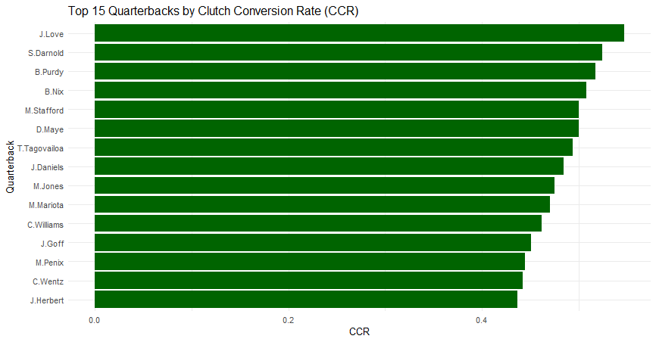
I did not have any expectations for who would appear in the top 15, so I was surprised by the entirety of the output. The biggest surprises were Jordan Love and Tua Tagovailoa for contrasting reasons. I thought that Jordan Love had been having a good season, but I didn’t realize that he was so strong in the “big” moments, especially to lead the NFL (with a qualifier of a minimum of 15 clutch moments faced). Tua on the other hand, is the face of a Miami struggling team and has been ridiculed for his play this season, so seeing his name show up as the 7th most productive QB in big moments was quite surprising. My theory is that because the Dolphins have had so many opportunities where they have been within 7 points of their opponent within the fourth quarter, in which Tua has produced, that his percentages stack up favorably with the rest of the league.
It is important to note that the biggest names in the league are not even on this list. Patrick Mahomes, Josh Allen, and Lamar Jackson who were the favorites for the MVP race last season are all ranked 21st or below in CCR. That is not to say they are having subpar seasons either but rather that their teams might not have been in these high leverage situations that much or that they have not had to produce in order to win. For example, Jordan Love, who ranks first in this list, leads the Green Bay Packers who have a record of 2-1-1 this season while Josh Allen, who ranks 30th and has a CCR over 18% worse, leads a Bills team with a record of 4-1. These two teams simply have had contrasting wins and situations where Love has been in the thick of these huge moments more often and has had to produce whereas Allen has strung together impressive quarterback performances that do not show up in this metric yet contribute to team victories.
Other conventional passing statistics that evaluate quarterback performance do line up with CCR data better than team success. For example, the NFL’s passing yards leader is Matthew Stafford, touchdowns leader is Jared Goff, and the top three for completion percentage amongst starting quarterbacks are Jared Goff, Drake Maye, and Sam Darnold. All of which appear within the top 15 of the CCR, as do 5 of the top 7 quarterbacks in passer rating.
Using CCR as a player metric, as it was initially designed in this instance, seems to be its limitation at the moment, comparing well to other notable statistics positionally. However, it is not without its faults, missing the stars of the position and failing to consider variation of team success. I think further expansion of the CCR will need to revise its situational outlooks and ensure that it can project for all positions, or it will end up being labeled as a single position metric.
- Telling a Story with Data: Evaluating Sport Visualizations
Telling a story with data allows the creator to speak to the audience and quickly communicate to them what they need to know. An effective story is short, cohesive, clear, and well represented by the data being presented. Best accompanied by an effective visualization, a story should convey the data to the audience in a meaningful way and leave them feeling like they took something of value from what was being presented.
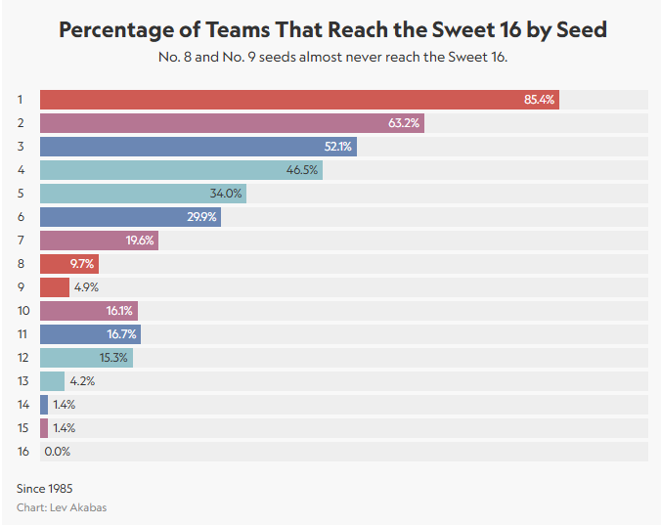
When looking at the visual above, I think it tells a clear story: the higher the seed, the better the chance of reaching the Sweet 16 in March Madness. I think the horizontal bar chart does an excellent job showing how vast of a disparity there is between the higher seeds and the lower seeds as well, but I think where this visual really falls flat is an overuse of color. If their intention is to highlight the 8th and 9th seed as hinted in the subtitle, then I would borrow from Ms. Knafflic’s toolbox and gray out the remaining bars to focus emphasis on those in which the creator is attempting to draw attention to. The more intriguing story is actually the spike after the 8th and 9th seeds, seen in the lower 10th through 12th seeds. However, on a purely visual evaluative basis, the color and inability to focus attention are the main detractors that I see.
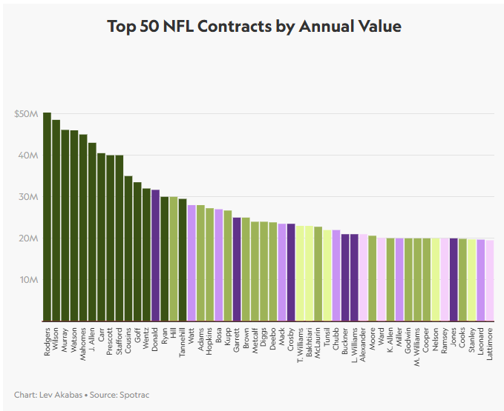2
The whole point of this visual above was to illustrate that Aaron Donald, following the Rams Super Bowl victory, was given a raise to become the highest paid non-QB in the NFL. If I had not read the paragraph attached to this visual telling me that information, I would not have known that was the intention. The visual lacks critical context and is extremely cluttered. Additionally, while I understand the intention of color coding position, with the number of players chosen it is just a color overload. Rather than telling the story that I am supposed to be interpreting, I am spending time dissecting a list of who the 50 highest paid players in the league are and what positions they play, based on the chosen color scheme. The visual lacks cohesive context, promotes clutter, bombards the viewer’s focus, and tells a misleading story from the creator’s intention.

- Telling a Story with Data: Creating Sports Visualizations
The following two visualizations represent the beginning of my exploration of the Big Data Bowl data.
My first visualization represents the top speeds registered by defensive backs during plays within the first week of the 2023 season. My initial Big Data Bowl interest surrounds the defensive backs on the impending catch point, so this analysis was to evaluate how fast the general speeds of the positions were, and a cursory look at if there were any brief trends in the data (were the players running fast because they were out of position on a route/running to make a tackle, etc.).
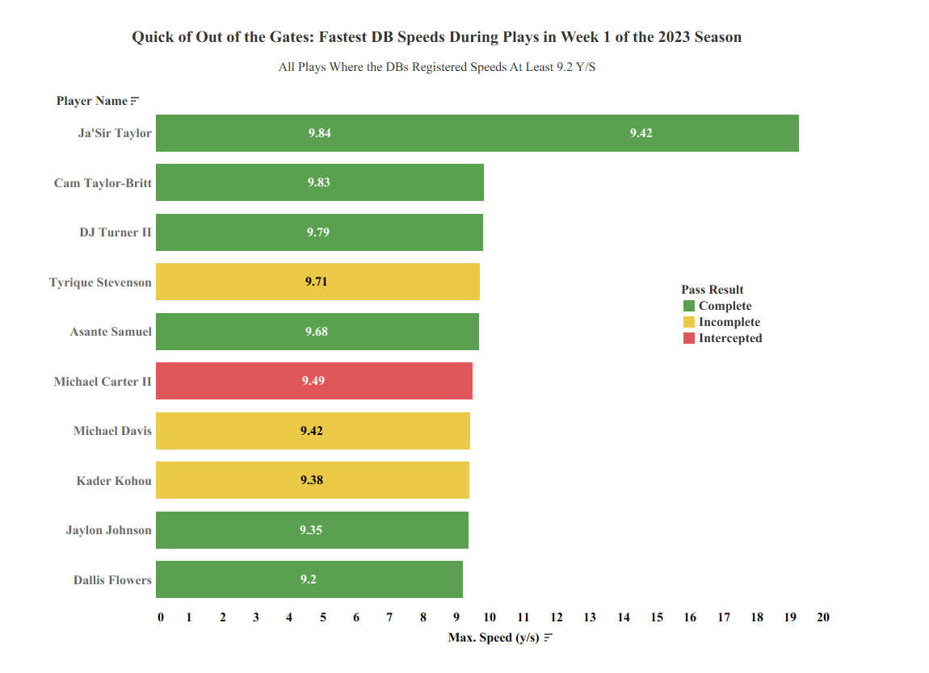

My second visualization is focused on acquainting myself with the data and understanding what the various fields and data markers available within the set are. In this case, I was thinking about the intense situations at the end of a football game where a team needs to drive down the field quickly, usually by passing the football. My visual displays the difference routes ran by the targeted receivers in plays run with under two minutes remaining in the fourth quarter of games, and the average yards gained by each specific route option.
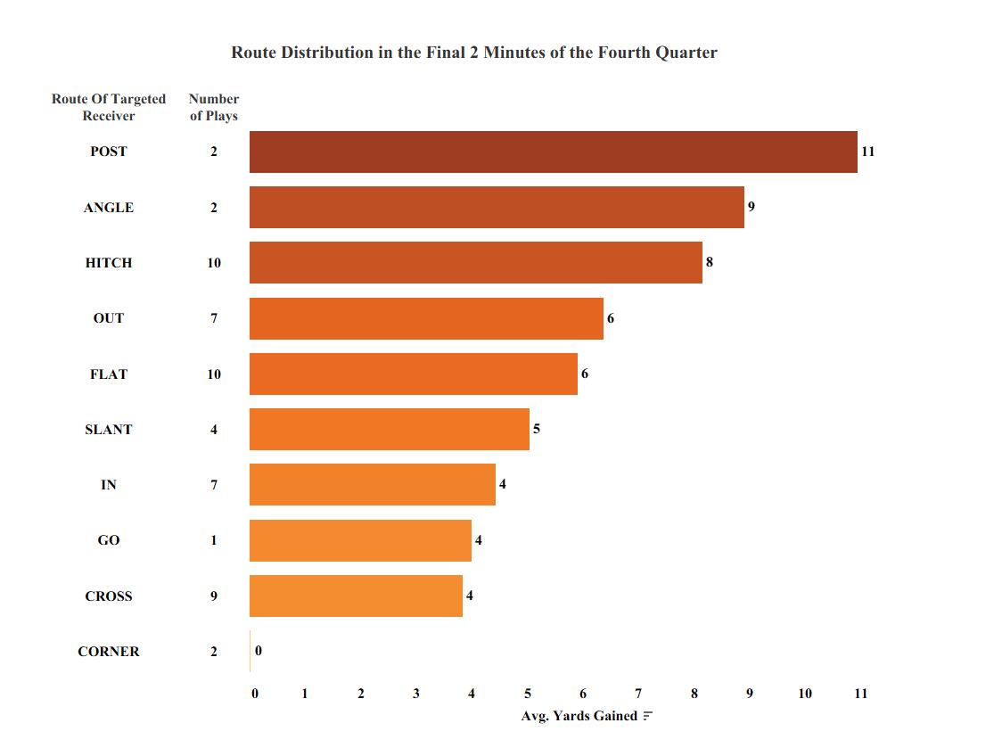

SSAC25: Minding the College Football Analytics Gap
Best Data Visualization of 2022: Sportico's Charts of the Year

